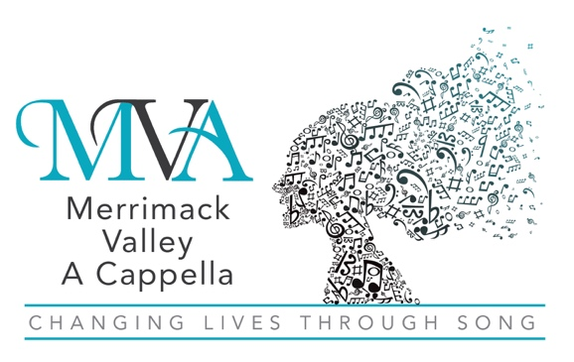
A Chapter of Sweet Adelines International

Date:
Name
Address
City, State ZIP

Dear ,
On behalf of Merrimack Valley A Cappella, thank you and your business for your generous support of our 2023 Cabaret and Silent Auction with your gift of $__________________ or __(item)______ on XX/XX/XXXX.
Your contribution is an integral part of our success as a non-profit entity. We strive to represent women’s a cappella music and “Harmonize the World” with our song. Locally, we enjoy sharing our energy and sound with our communities, which is only possible with your support.
At Merrimack Valley A Cappella, we are “Changing Lives Through Song.” Thank you again for your support and generosity!
Regards,

Member, Merrimack Valley A Cappella

Merrimack Valley A Cappella is a 501(c)(3) non-profit organization.
Your contribution is tax-deductible to the extent allowed by law.
No goods or services were provided in exchange for your donation.
Tax Identification Number: 23-7446582

