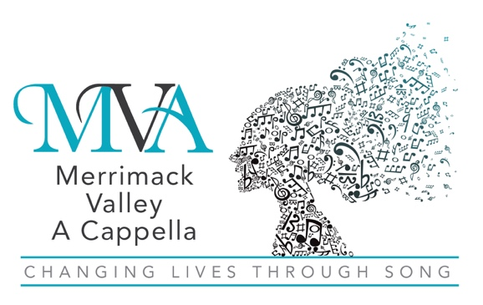 A Chapter of Sweet Adelines International
A Non-Profit 501(c)(3) Educational Organization
Dear Supporter,

As a patron of your business, I would like to present you with an opportunity to support our chorus, a non-profit educational organization in your community, while also promoting your own business. First, let me share with you some information about the organization.

Merrimack Valley A Cappella (MVA) is an award-winning singing group of women from Greater Boston and Southern New Hampshire. Celebrating fifty years as a Chapter of Sweet Adelines International, we share a love of singing and performing with over 25,000 women throughout the world. Each of us gets tremendous satisfaction from sharing our sound with communities and organizations throughout Massachusetts and Southern New Hampshire.

We offer the opportunity to show your support by purchasing an ad or a listing in our annual program book. This book will be distributed to all attendees at our annual show on November 2, 2025 in Andover, MA. We may also distribute these books at other events where we participate, perform, or attend.

For the cost of an ad, you would receive:

- Direct marketing at our major fall performance
- One full year of advertising throughout Massachusetts and Southern New Hampshire
- A tax deduction
- The satisfaction of helping Merrimack Valley A Cappella continue to achieve musical excellence

In the spirit of supporting the community that supports you, please consider placing an ad. Your support will allow us to continue our musical education programs and achieve our goals.

If you would like to place an ad, please use the attached form.

If you have any questions, please feel free to contact me. Thank you in advance for your generosity.

In Harmony,

______________________________________________________________________________________

______________________________________________________________________________________
(Member's name and contact information)

