
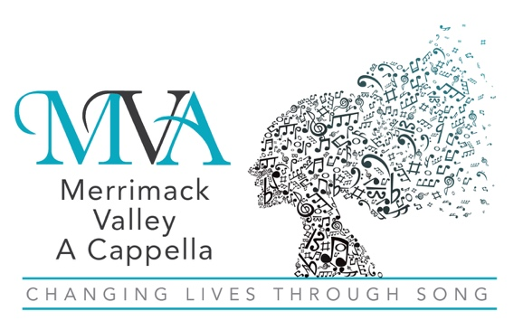
A Chapter of Sweet Adelines International
A Non-Profit 501(c)(3) Educational Organization

Date:

Date: _________,

Name
Address
City, State ZIP

Dear _________,
On behalf of Merrimack Valley A Cappella, thank you and your business for your generous support of our 2025-2026 ad book with your gift of $XXX.XX on XX/XX/XXXX. We value your contribution and are glad to present your advertising during our annual showcase. We hope you can join us for our show on November 2, 2025 at Temple Emanuel in Andover, MA.
Your contribution is an integral part of our success as a non-profit entity. We strive to represent women’s a cappella music and “Harmonize the World” with our song. Locally, we enjoy sharing our energy and sound with our communities, which is only possible with your support.
At Merrimack Valley A Cappella, we are “Changing Lives Through Song.” Thank you again for your support and generosity!
In Harmony,

Member, Merrimack Valley A Cappella

Merrimack Valley A Cappella is a 501(c)(3) non-profit organization.
Your contribution is tax-deductible to the extent allowed by law.
No goods or services were provided in exchange for your donation.
Tax Identification Number: 23-7446582

